logo_ryerson

Department of Electrical & Computer Engineering

Programs: Electrical & Computer Engineering

|  |  |
| --- | --- |
| Course Number | **ELE635** |
| Course Title | **Communication Systems** |
| Semester/Year | **Winter 2019** |
| Instructor | **Ngok-Wah Ma** |

|  |  |
| --- | --- |
| **Lab Report No.** | **3** |

|  |  |
| --- | --- |
| Report Title | **Experiment 3: Frequency Modulation and Demodulation** |

|  |  |
| --- | --- |
| Section No. | **10** |
| Group No. |  |
| Submission Date | **March 26th, 2019** |
| Lab Performed Date | **March 26th, 2019** |

|  |  |  |
| --- | --- | --- |
| Name | Student ID | Signature\* |
| Vatsal Shreekant | *xxxx71363* |  |

(Note: remove the first 4 digits from your student ID)

*\*By signing above you attest that you have contributed to this submission and confirm that all work you have contributed to this submission is your own work. Any suspicion of copying or plagiarism in this work will result in an investigation of Academic Misconduct and may result in a “0” on the work, an “F” in the course, or possibly more severe penalties, as well as a Disciplinary Notice on your academic record under the Student Code of Academic Conduct, which can be found online at:*

[*www.ryerson.ca/senate/current/pol60.pdf*](http://www.ryerson.ca/senate/current/pol60.pdf)*.*

**A.1.** when the amplitude of single tone modulated FM signal (Am) increases from 2V to 10V peak-to-peak, the spectrum of FM signals spectral nulls increases, and the bandwidth of the signal also increases. Equally, it was observed that when Am increases causing the height of spectral nulls to decrease. As frequency (Fm) of modulating signal *m(t)* was gradually decreasing from 1kHz to 100Hz, the spectrum of FM signal changed by an increase in spectral nulls, and a decrease in height of spectral nulls. The bandwidth remained the same when decreasing the Fm from 1kHz to 100Hz. Comparing Am to Fm, it was clear that the bandwidth changed proportionally with Am and stayed constant when changing Fm.

**A.2.** If the modulating signal *m(t)* was equal to Amsinωmt and ΦFM(f) is its one-sided rms spectrum, and m’(t) = KAmsinKωmt where K is a positive integer and Φ’FM(f) is its one-sided rms spectrum, it was observed that ΦFM(f) and Φ’FM(f) were identical. Ideally, ΦFM(f) and Φ’FM(f) are equal since they have the same carriers. For example, if KAm = A’m, where Wm = 2πfm, and KWm=W’m it is evident that K values in FM modulation index (β) equation will cancel and result in equal ΦFM(f).

**B.1.** Based on the calculations that were gained through Steps B.1-B.2, β was calculated using Appendix A.1 matching the values taken from the frequency spectrum (J values) along with Am =0; once β was known, the parameter for Kf was investigated using the equation:

$$β=\frac{k_{f}A_{m}}{2πf_{m}}$$

$$k_{f}=\frac{β2πf_{m}}{A_{m}}$$

**Table 1:** The First Spectral Null

|  |  |
| --- | --- |
| **First Spectral Null** | |
| $f_{c}$ | 1 kHz |
| $$A_{m}$$ | 9.3 V |
| $$K_{f}$$ | 1.587 kHz/V |
| $$β$$ | 2.35 |

Determining $A_{m}$ when $β$ **= 0.2**, **1**, **5** when $f_{m}$ **= 1 kHz** and $K_{f}$ **= 3.45 kHz/V**

$$β= \frac{K_{f}A_{m}}{2πf_{m}} ⟶ A_{m}= \frac{β2πf_{m}}{K_{f}}$$

$$β=0.2 A_{m}= \frac{(0.2)2π(1000 Hz)}{3450 Hz/V}=0.364 V$$

$$β=1 A_{m}= \frac{(1)2π(1000 Hz)}{3450 Hz/V}=1.821 V$$

$$β=5 A_{m}= \frac{(5)2π(1000 Hz)}{3450 Hz/V}=9.106 V$$

One-Sided RMS Spectrum with $β=0.2$, $f_{m}$ **= 1 kHz**, $K_{f}$ **= 3.45 kHz/V**

**B.2.** In this experimentation, it was observed that [ΦFM(f)] rms is the rms value of the FM signal $φ_{FM}\left(t\right)= A_{c}cos⁡(ω_{c}t+βsinω_{m}t)$. According to the measurements that were taken from Steps B.4-B.6 for $β$ equal to 0.2, 1 and 5 the rms value of the FM signal was 0.257, 1.287, and 6.439 respectively. Prelab 3 that was written for this experiment shows the theoretical calculation (Question 1b). Also, **Table 7** refers to RMS values at these modulation indices.

**B.3.** Carson’s rule as well as the 1% rule was used to approximate the bandwidth of FM signal with modulation indices 0.2, 1, and 5. **Table 2** and **Table 3** show the estimated bandwidths for both the Carson’s rule method and the 1% rule method. Carson’s rule allowed us to use Bfm = 2nmax(fm) where the fm was equal to 1kHz to come up with an approximation for the bandwidth. The 1% rule is useful for to use the universal curve represented through **Figure 1** to distinguish the corresponding bandwidths.

**Table 2:** Bandwidth using Carson’s Rule

|  |  |
| --- | --- |
| **Bandwidth for Specific Modulation Indices** | |
| $β$ | **BFM** |
| **0.2** | 4.4 kHz |
| **1** | 6 kHz |
| **5** | 14 kHz |

From Carson’s Rule:

$$B_{FM}=2(∆f+ B_{m})$$

$$f_{m}=1 kHz$$

$$∆f= β x f_{m}$$

$$B_{m}=2 x f_{m}$$

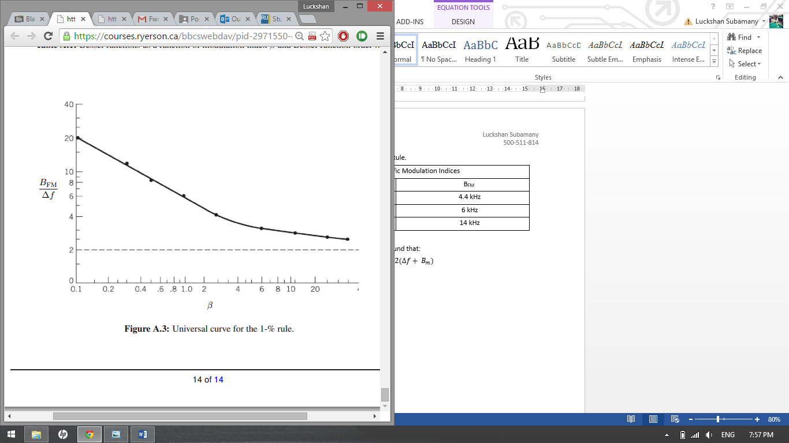

**Figure 1:** Universal Curve for 1% Rule

**Table 3:** Bandwidth using Universal Curve for 1% Rule

|  |  |
| --- | --- |
| **Bandwidth for Specific Modulation Indices** | |
| $$β$$ | **BFM** |
| **0.2** | 2 kHz |
| **1** | 6.5 kHz |
| **5** | 17 kHz |

**C.1. 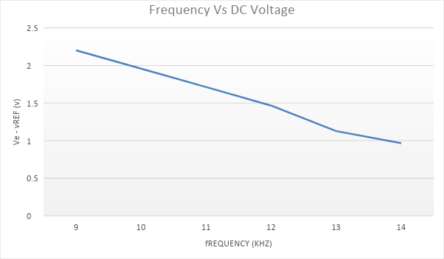**

**Figure 2:** Graph of frequency for fi increased from **4 kHz** vs Ve -Vref.

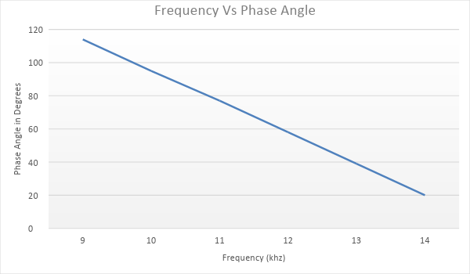

**Figure 3:** Graph displaying frequency for fi increased from **4 kHz** vs Phase Angle

**C.2.**

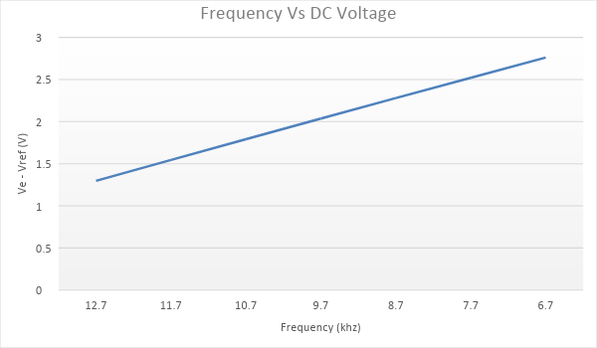

**Figure 4:** Graph of frequency for fi decreased from **16 kHz** vs **Ve-Vref**

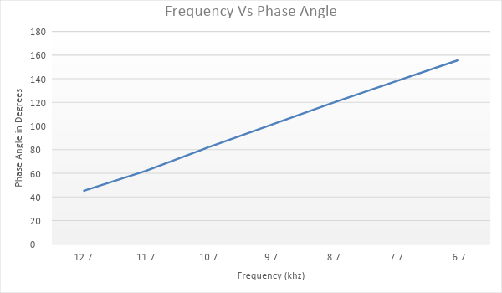

**Figure 5:** Graph of frequency for fi decreased from **16 kHz** vs **Phase Angle**

**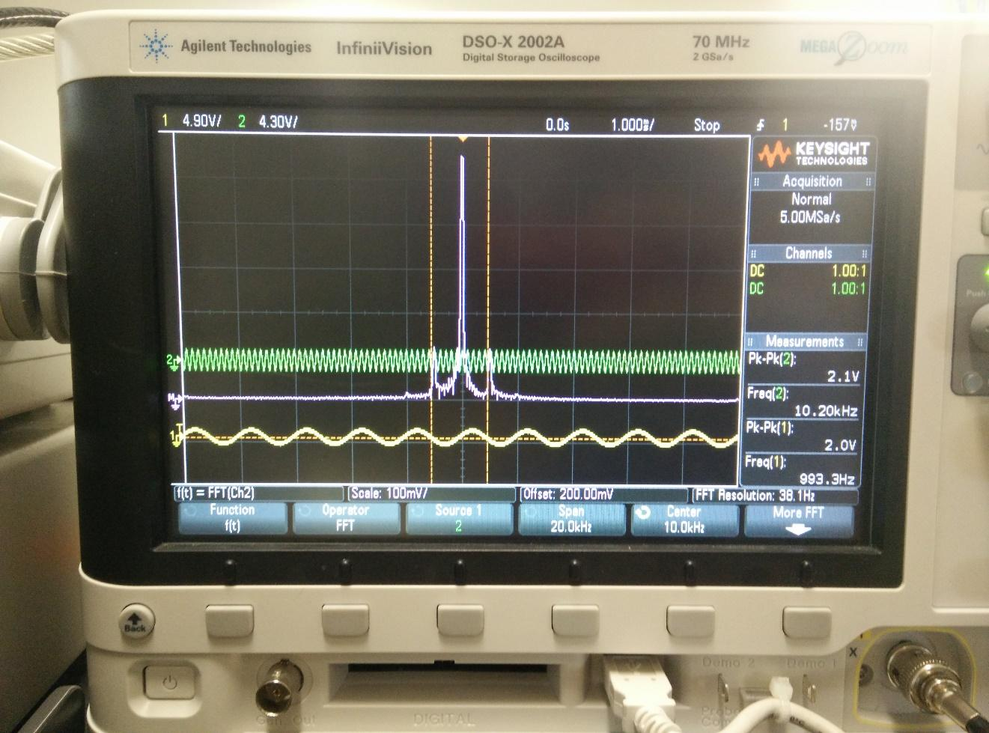C.3.** Figure 2 indicates the connection diagram to measure phase-locked loop (PLL) features. When input signal frequency fi was slowly increased, it was noticed that the trace of the signal suddenly matches and remains that way when the DC voltage Ve at the [DEM out] was at 7.866V. The trace was coordinated right after a frequency of 8.5KHz which is known as fP. From the measurements measured in Steps C.2-C.3, Figures 2 and 3 indicate the Ve-Vref graphed vs fi when increased from 4KHz and the phase Vo (t) and Vi (t) graphed vs frequency for fi when increased from 4KHz. Similarly, for Step C.4, Figures 4 and 5show the plot of Ve-Vref vs frequency when fi decreased from 16KHz and the phase between Vo(t) and Vi(t) vs frequency when fi decreased from 16KHz. When fi was slowly increased from 4KHz to fp, fi tends to be less than fp and results in some few isolated narrow-band frequency positions as input and output voltages were corresponding. This fact was due to the frequency change from Channel 1 and Channel 2 of system by the perseverance to become coordinated at that one moment. Also, when frequency is not locked to PLL, the voltages will stay at bias values.

**Figure 2.**The oscilloscope’s spectrum of the FM signal when $m\left(t\right)$ is at **2 V** is shown.